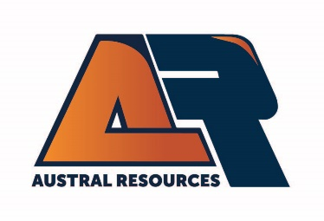
Environmental Officer – Copper Mine

Austral Resources (ASX:AR1) owns and operates the Lady Annie and Anthill Mining Projects, and the Mt Kelly Processing Facility. The operations produce LME Grade A copper cathode.

Located 120km north-west of Mt Isa, the position is DIDO from Mt Isa, or FIFO from Brisbane, Townsville or Cairns is available with flights supplied.

About the role:
Reporting directly to the Site General Manager, you will be responsible for the ongoing development and delivery of successful environmental system initiatives, setting the strategic direction, and delivering on environmental targets. You will ensure compliance with legislative obligations and requirements of the Site Environmental Plans.

Key Responsibilities
- Leading the ongoing development and maintenance of the Environmental Management System.
- Carrying out environmental monitoring and inspections as per EA requirements. This includes, but is not limited to, groundwater, surface waters, stream sediments.
- Establishing best practice environmental rehabilitation programs.
- Ensuring diligent compliance with environmental licence and statutory requirements.
- Assisting with preparing and managing environmental budgets.
- Leading environmental incident investigations and reporting requirements and implementing corrective actions.
- Access and complete Permit to Disturb requests.
- Building effective, credible, and sustainable relationships with all stakeholders.
- Knowledge of and commitment to adhering to Site Safety Systems and industry practices.
- Completion of monthly environmental monitoring report.

The successful candidate will demonstrate the following skills and experience:
- Tertiary qualifications in relevant Environmental discipline/s is essential
- Experience working within the mining industry.
- S123 Site Supervisor accreditation is desirable.
- GIS Mapping experience.
- Sound knowledge of NPI, NGERS reporting requirements.
- In-depth knowledge of State and Federal Environmental Legislation.
- Skilled with conducting risk assessment, hazard identification & responsive to safety issues.
- Able to demonstrate your skills in prioritisation, planning and organising.
- Exceptional stakeholder engagement skills.
- Able to demonstrate the use of good judgement, decision-making, and problem-solving capabilities.
- Professional level of written and oral communication skills.

Benefits
- Remuneration will be commensurate to the skills and experience of the successful applicant.
- Site amenities include a fully equipped modern camp facility with ensuite rooms, gym, pools, wet mess, internet room and NextG coverage.
- All transport and meals are provided.

Eligibility:
Candidates must be domiciled and eligible to work in Australia (without requiring sponsorship) to be considered for employment with Austral Resources.
As an Equal Opportunity Employer, we encourage people from diverse backgrounds to apply.
Further information about Austral Resources is available on the Company’s website.
www.australres.com

