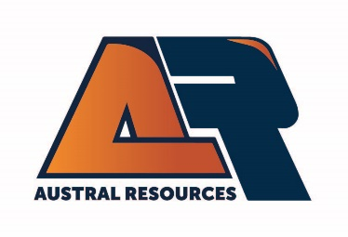
Mine Surveyor

As a valued member of the Mine Technical Services team, you will be responsible for the day-to-day setout of designs and providing plans to operators to ensure the excavation process is completed appropriately to design at the Anthill pit.
Safety is a core value at Austral and we expect all levels of employees to always act in a manner that seeks to enhance the safety culture and performance of our operations.
This role is offered on 12 days on, 9 days off roster and is FIFO from Brisbane, Townsville or Cairns
Duties of the role:
- Demonstrate safety leadership and a commitment to a zero-harm culture
- Maintain survey control by toe and crest markups, batter checks, ramp setouts, blast boundary setouts and TBM’s
- Assist geologists with ore markups and blast vector monitoring
- Installation of prisms for high wall and berm monitoring and analysis of prism observations
- Pit pickups (RTG GPS or Aerial drone surveys).
- End of month stockpile surveys and report
- End of month volume calculations for contract payment

About You:
You will have:
- Tertiary Qualifications in Mine Surveying (Diploma or higher)
- A minimum of 2 years experience as an open-pit mine surveyor
- Excellent time management and organisational skills with the ability to work independently and demonstrate initiative
- Experience with Trimble GPS
- Experience using MS Office and Surpac software is essential
- Experience with Pix4D software will be highly regarded
- Possess a current manual driver’s license
- Demonstrate excellent communication skills

ELIGIBILITY:
- Candidates must be domiciled and eligible to work in Australia (without requiring sponsorship) to be considered for employment by Austral Resources.

Further information about Austral Resources is available on the Company’s website www.australres.com

