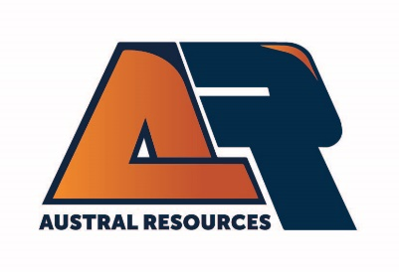
Mining Engineer
Anthill Open Cut Copper Mine
As a valued member of the Mining team, you will be responsible for providing quality technical services and working collaboratively with the broader technical services team to ensure optimal execution of the Anthill pit mining schedule.
Safety is a core value at Austral and we expect all levels of employees to always act in a manner that seeks to enhance the safety culture and performance of our operations.
This role is offered on 12 days on, 9 days off roster and is FIFO from Brisbane, Townsville or Cairns.
Duties of the role:
• Demonstrate safety leadership and a commitment to a zero-harm culture
• Compliance with Legislative requirements
• Maintain Mining Plan, including:
o Drill and blast design
o Medium-long term scheduling
o Open pit design
o Waste dump design
o Traffic management design
• Prepare operational sequence diagrams & mining instructions
• End of month calculations
• Data manipulation
• Blast control duties
About You:
• Mining Engineering Qualifications
• Current Australian Drivers Licence
• Minimum 2 years’ experience working at mining operations
• First Aid Training – HLTAID011 would be advantageous
• Supervisor training (RIIRIS301, RIIWHS301, RIICOM301) would be advantageous
• Demonstrate excellent communication skill

Remuneration will be commensurate to the skills and experience of the successful applicant.
Site amenities include a fully equipped modern camp facility with ensuite rooms, gym, pools, wet mess, internet room and NextG coverage. All transport and meals are provided.
Eligibility:
Candidates must be domiciled and eligible to work in Australia (without requiring sponsorship) to be considered for employment by Austral Resources. Further information about Austral Resources is available on the Company’s website.
www.australres.com

